Q5. Dijkstra – Navigation System
AIM
To implement Dijkstra’s Algorithm to find the shortest path between locations in a navigation system and analyze its time complexity.
ALGORITHM
1. Represent locations as vertices and roads as weighted edges.
2. Initialize the source distance as 0 and all other distances as infinity.
3. Insert the source vertex into a priority queue.
4. Remove the vertex having the minimum distance.
5. Check all its adjacent vertices.
6. Update the distance if a shorter path is found.
7. Insert the updated vertex into the priority queue.
8. Repeat until all required vertices are processed.
9. Display the shortest path and its distance.
SAMPLE INPUT
Vertices = 4
Edges:
A B 4
A C 2
B D 5
C D 1

Source = A
Destination = D

SAMPLE OUTPUT
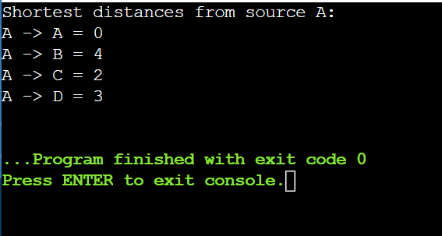
Shortest Path: A -> C -> D
Shortest Distance: 3
TIME COMPLEXITY ANALYSIS
For Dijkstra’s Algorithm:

• Using adjacency matrix: O(V²)
• Using adjacency list + priority queue: O((V + E) log V)
• Using Fibonacci heap: O(E + V log V)

Where:
V = number of vertices
E = number of edges

For navigation systems, adjacency list with a priority queue is preferred because it provides efficient shortest-path computation for large graphs.

